**BASIC WORK FLOW**

**ART REQUIRMENTS:**

2D Sprites Self Evaluation

1. Player Sprite Time required:

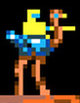 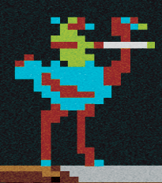

1. Enemy Sprite Time required:

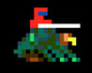 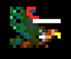 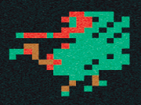

1. Pterodactyl Time required:



1. Platforms Total Time required:
2. With Spawners Time required:



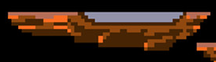 

1. Without Spawners Time required:



1. Lava and bridge over it: Time required:

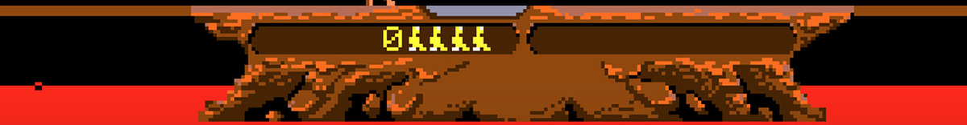

1. Basic UI: Time required:



1. Eggs: Time required:



1. Hatched Birds: Time required: